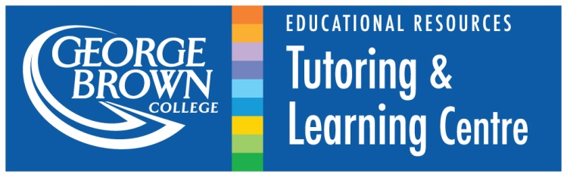
Peer Tutor Passport
English
Passport # 3
Name : _______________

This passport is designed to help you expand your familiarity with TLC resources and policies and develop your skills as a tutor. Please use your non-tutoring time in the TLC to complete this passport within one semester. It is important that you complete the first 4 goals in this passport prior to intersession (mid-semester break) and the last 4 before your tutor-evaluation at the end of the semester. Consult with your Advisor if you have any questions or difficulties completing any of your goals, and remember to turn it in for review once you have completed all goals.

GOAL 1: Create a S.M.A.R.T goal for the semester.
(Make sure to share your goal with your TLC Advisor and ask questions if needed.)

S.M.A.R.T goals are used to ground your development and help you move forward in a measurable and realistic way.
Specific – A specific goals has a better chance of being achieved. You should be able to answer WHO (is involved); WHAT (do I want to accomplish); WHEN (establish a timeline); WHICH (requirements and constraints); and WHY (purpose or benefits)
Measureable – You need to establish solid criteria for measuring progress toward the goal you are setting. You should be able to answer: “How will I know it has been accomplished?”
Attainable – Goals need to be realistic in terms of setting an objective that you are both willing and able to work toward. Don’t confuse an ambitious goal as being unrealistic. Only you can decide just how high your goal should be.
Relevant –With specific goals that have concrete steps and a timeline, almost any goal is attainable. But is it worthwhile? As a tutor, how will this goal meet the needs of the TLC or TLC clients?
Timely – All goals should have a timeline. Goals are more attainable when grounded in a specific timeline. “Someday” is not a timeline. Set a realistic timeline and you have more opportunity to achieve your goal.

Write your SMART goal here: (How do you plan to improve as a tutor this semester?)

In the spaces below, explain how the goal, which you’ve identified above, meets the criteria below:
Specific
Measureable
Attainable
Relevant
Timely

GOAL 2: Develop your tutoring strategies
Watch the following video: https://www.youtube.com/watch?v=RsbqtMOAgg8

After watching the video, write a detailed reflection paragraph on how this video might inform your future tutoring sessions.

GOAL 3: Develop your grammar skills

The sentences below exhibit common grammar or sentence-structure problems.

A) Circle the problem(s) in each sentence, and if possible identify the type of problem(s) (ie: Run-on sentences, verb tense, articles, etc) and correct it. Check your answers with your Advisor before continuing.

B) Choose 2 of the sentences that you could not identify the problems for, or are unfamiliar with.

- Identify an appropriate resource that would help to explain this grammar error.
- In the space provided explain how you might help a student understand the error

- I gave pastries to my friends that had feta cheese.
- The student avoided to talk to his professor.
- The shelf holds, so you can place things on it.
- If I was you, I wouldn’t be late for your shift.
- Go to the park is a good way to get exercise.
- Michael always insists that the tutors are professional.
- Needed milk, she went to the store.
- There was anyone in the class. I was completely alone.
- If you don’t work hard, more likely you will be trying instead of succeed.
- Have you ever thought to drop high school?
Which sentences have you chosen to discuss?
a) __________________________________________________________

Grammar issue: _________________________

Explain how you would explain how to correct this problem to a tutor. Don’t forget to mention resources that would be helpful for the student!

b) __________________________________________________________

Grammar issue: _________________________

Explain how you would explain how to correct this problem to a tutor. Don’t forget to mention resources that would be helpful for the student!

GOAL 4: Build your understanding and ability to explain summary and paraphrase

Use resources available in the TLC and through the TLC website to answer the questions below. Provide references to the resources you will use here:

- Define the terms summary and paraphrase.

Summary

Paraphrase

When do students usually need to paraphrase? Provide at least 3 examples of where students will be able to apply their paraphrasing skills.

1.

2.

3.

Why is it often better to paraphrase research rather than quote?

When is it appropriate to summarize information? Provide at least 3 examples where summary can be used effectively in an assignment.

Build your understanding and ability to explain summary and paraphrase

- How would you respond to the following tutoring situations?

A student comes into the TLC for help with an assignment on paraphrasing short passages. The student tells you that his method for completing the assignment was to simply use a thesaurus to find synonyms for each of the words in the paraphrase. The sentence structure and punctuation remain that of the original.

A student comes into the TLC for help writing a summary of an article for a class. She understands the basics of what a summary is supposed to be but asks you. “How can I find the main ideas?”

While reading through a research essay, you notice that whenever the student refers to research his language suddenly sounds really advanced compared to his own sentences which tend to be a little simpler, and often contain vocabulary errors. When you ask if whether he is quoting or paraphrasing his research he says, “paraphrasing”. You suspect he may be committing plagiarism but you are not sure if he is doing it on purpose.

You notice that a student is relying heavily on quotations for his research support. When you advise him to try to paraphrase the passages he says that he can never think of a better way to say it than the original, and so quoting is easier.

GOAL 5: Discuss dealing with inappropriate behaviour in the TLC
- All of the topics listed below could be potentially problematic if they come up during a tutoring session, or while you are in the TLC. Of these topics, which 2 do you think would never be appropriate to discuss in the TLC? Briefly explain why you think so.

Past relationships  Cultural Stereotypes  Politics | Physical and mental health issues  Other tutees/tutors  Religious affiliations  Private tutoring | Sex  Gossip  Unfair teachers

Explain:
1.

2.

- Of the topics you did not circle, choose one to discuss. In what circumstances might it be appropriate to discuss these topics, and in what circumstances would you need to divert the conversation to a more appropriate topic? How would you do so?

A student you are working with makes some potentially offensive comments about another student’s race or sexuality during your session. As an employee of George Brown you know that such behavior shouldn’t be tolerated, but you want to get the student back on track. What is an appropriate response to these comments?

Bonus for English tutors: What if such comments were made in a student’s argumentative essay?

GOAL 6: Develop transferable work skills: Intercultural communication
The Tutoring and Learning Centre at George Brown College serves a highly diverse community of students. As a TLC Peer Tutor, you should be prepared to work with students coming from a variety of backgrounds and life experiences.
- INTERCULTURAL COMMUNICATION
What does intercultural communication mean to you?

Choose ONE article on intercultural communication from the following resource:
http://www.kwintessential.co.uk/cultural-services/articles-intercultural.html
Which article did you choose?

Reflect on the article that you have read. What are the main ideas presented in the article? How can you implement these ideas in your tutoring practice at the TLC or your future career?

The Do’s and Don’ts of Intercultural Communication.
Read each statement below and label it as either a “do” or a “do not” on the line beside it.
_______ be patient
_______ use plain, direct language
_______ check for understanding
_______ make assumptions
_______ be aware of your nonverbal communication (e.g. hand gestures, eye contact)
_______ respect personal space
_______ ask for clarification, if needed
_______ accept bribes or elaborate gifts
_______ use active listening skills
_______ tell jokes that may be misinterpreted in any way
_______ put your feet up on the chair during a tutoring session
_______ be aware that the same gesture can mean different things in different cultures
_______ treat all people as individuals
_______ make unfair judgements about a person or another culture
_______ pay attention to others’ nonverbal communication cues
_______ be very careful about touching in any way
_______ perpetuate stereotypes
_______ be polite and respectful at all times
_______ explicitly encourage students to ask questions
_______ examine your own culture with a critical lens
_______ use symbols, diagrams and pictures when appropriate
_______ be professional at all times
_______ expect students to understand idioms and culture-specific expressions
_______ eat during a tutoring session
_______ rely on “common sense” as this may be culture-specific
_______ be open to new ideas and ways of doing things
_______ reflect on your experiences and learn from them

GOAL 7: Learn about working with students with disabilities
Visit the following website: http://opened.uoguelph.ca/en/students/resources/uid_brief_2015.pdf
What are the principles of Universal Instructional Design (UID)?
1.
2.
3.
4.
5.
6.
7.
How do you/can you incorporate these principles into tutoring sessions?

Why might it be a good idea to incorporate these principles into ALL of your tutoring sessions?

GOAL 8: Develop transferable work skills: Leadership
“If your actions inspire others to dream more, learn more, do more and become more, you are a leader.” – John Quincy Adams
“A leader is one who knows the way, goes the way, and shows the way.” – John Maxwell
“A leader is best when people barely know he exists, when his work is done, his aim fulfilled, they will say: we did it ourselves.” - Lao Tzu
- In your opinion, what are the qualities of a good leader?

- Thinking back on your experience at the TLC, describe a specific situation where you exhibited leadership skills.

- What leadership opportunities have you been able to develop at the TLC? How will these qualities help you succeed in the future?

Reflect on your experience as a tutor.
As a tutor, reflection is often one of your greatest tools.
With that in mind what is…
…your greatest strength as a tutor?
Why do you consider it your greatest strength?
How do you apply this strength when tutoring?

Now, did you accomplish your Smart Goal?
…if ‘no’, why not?
If ‘yes’, how did it impact your tutoring sessions?
What were the biggest obstacles you faced in achieving your SMART goal?

Congratulations on completing all of your Passport Goals!

Please take a moment to help us continue to provide effective tutor skill development and tutoring support by answering the following survey questions:

- Which goal(s) did you find were most helpful to your skill development?

- Which goal(s) did you have the most difficulty completing? Why?

- Which goal took the longest to complete? (Approximately how long in total?)

- Which goal took the shortest time to complete? (Approximately how long in total?)

- Do you have any questions about the content of the passports?

Please turn the completed passport in to your TLC Advisor prior to your end-of-term evaluation.

I’m done; now what?
If you complete your passport early, and would like to continue developing your tutoring skills during your down-time, please feel free to complete additional items. Please attach any additional work you do to this passport.

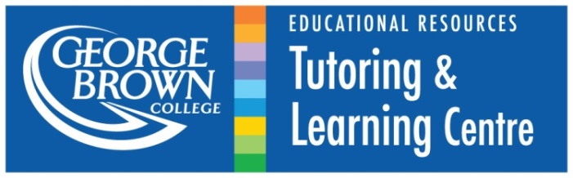
Thank you for all your hard work and dedication!

